# File System Assignment

## Name: Mubasher Mehnaz Begum

## Course: CST - 221

## Assignment: CST – 221 File System

## Date: 07/12/2020

GITHUB LINK: <https://github.com/MubasherBegum/CST-221>

1. Explore the Linux File System in your VirtualBox Ubuntu installation. Document the purpose (two to three sentences) for each of the following directories.

|  |  |
| --- | --- |
| **Directory** | **Purpose** |
| / | This is the root directory of the entire file system hierarchy. The tree starts from this directory. The write privileges to this directory are available to only Root user |
| /bin | The /bin directory contains essential binaries and common Linux commands which are needed in single user mode and to bring the system up or repair it. Examples are ls, grep, cp, cat. |
| /dev | This directory contains all device or special files that refer to the physical devices. These include usb, terminal devices or any other devices attached to the system. Examples such as /dev/usbmono, dev/tty |
| /etc | The /etc directory contains configuration files which are local to the machine. This also contains startup and shutdown shell scripts used to start/stop individual programs. Some larger software packages, like X11, can have their own subdirectories Examples are /etc/resolv.conf, /etc/logrotate.conf |
| /lib | The /lib directory contains library files that supports the binaries located under /bin and /sbin. Library filenames are either ld* or lib* |
| /boot | The /boot directory contains static files for the boot loader. It holds only the files that are needed during the boot process. Kernel initrd, vmlinux, grub files are located under /boot |
| /home | User’s home directory containing saved files, personal settings, etc are stored under home directory. Example would be /home/Mubasher which is my home directory on my Ubuntu |
| /mnt | This is a temporary mounted directory where system admins can mount filesystems. An example would be a temporary mounted network file system. |
| /proc | The virtual filesystem providing information on running processes and kernel as files for example /proc/uptime, /proc/{pid} |
| /tmp | The /tmp directory contains temporary files which may are created by system and users. The files under this directory when the system is rebooted. |
| /usr | The /usr directory is usually mounted from a separate partition. It contains only read only, sharable data that can be mounted by various machines running Linux. It contains majority of utilities and applications. |
| /var | The /var directory contains files that are Variable files whose content is expected to change continuously during normal operation of system like spool files, log files, backup files, messages or mailboxes. |
| /sbin | The /sbin directory is similar to /bin as it contains essential system binaries. Only difference is that the Linux commands that are located under this directory are only used by system administrators for system maintenance and not used by normal users. Examples are iptables, reboot, etc. |
| /kernel | I couldn’t find any information on this directory in Ubuntu manual. After some research, found that  **/lib/modules/kernel-version/** directory stores all compiled drivers under Linux operating system. ls -l /lib/mosules/$(uname -r) shows build -> /usr/src/linux-headers-5.4.0-37-generic. |

1. Using the Ubuntu *Files* (i.e., File Explorer) application go to the root directory of your system. For each directory under the root directory list the name of the directory and document its purpose (two to three sentences).

|  |  |
| --- | --- |
| **Directory** | **Purpose** |
| /bin | The /bin directory contains essential binaries and common Linux commands which are needed in single user mode and to bring the system up or repair it. Examples are ls, grep, cp, cat. |
| /dev | This directory contains all device or special files that refer to the physical devices. These include usb, terminal devices or any other devices attached to the system. Examples such as /dev/usbmono, dev/tty |
| /lib | The /lib directory contains library files that supports the binaries located under /bin and /sbin. Library filenames are either ld* or lib* |
| /libx32 | This directory is a variant of /lib on system which support more than one binary format requiring separate libraries (optional). In this case, the directory contains library that provides a 32 bit support. |
| /mnt | This is a temporary mounted directory where system admins can mount filesystems. An example would be a temporary mounted network file system.  The lib directory contains library files that supports the binaries located under /bin and /sbin. Library filenames are either ld* or lib* |
| /root | /root is the home directory of the root user. Non-root users do not have access to this directory. |
| /snap | The /snap directory is where the files and folders from installed snap packages appear on the system. |
| /sys | This directory contains information about devices, drivers and some kernel features. It provides a filesystem-like view of information and configuration settings that the kernel provides, much like /proc. |
| /var | The /var directory contains files that are Variable files whose content is expected to change continuously during normal operation of system like spool files, log files, backup files, messages or mailboxes. |
| /boot | The /boot directory contains static files for the boot loader. It holds only the files that are needed during the boot process. Kernel initrd, vmlinux, grub files are located under /boot |
| /etc | The /etc directory contains configuration files which are local to the machine. This also contains startup and shutdown shell scripts used to start/stop individual programs. Some larger software packages, like X11, can have their own subdirectories. Examples are /etc/resolv.conf, /etc/logrotate.conf |
| /lib32 | This directory is a variant of /lib on system which support more than one binary format requiring separate libraries (optional). In this case, the directory contains library that provides a 32 bit support. |
| /lost+found | This directory contains files that are lost in the filesystem. The files that may normally be lost because of directory corruption would be linked in the filesystem’s lost+found directory by innode number. |
| /opt | This directory contains optional application software packages. The directories /opt/bin, /opt/doc, /opt/include, /opt/info, /opt/lib, and /opt/man are reserved for local system administrator use. |
| /run | Runtime variable data, information about the running system since last boot. This directory contains system information data describing the system since it was booted. Files under this directory must be cleared (removed or truncated as appropriate) at the beginning of the boot process. |
| /srv | /srv contains site-specific data which is served by this system. For example, /srv/cvs contains CVS related data. |
| /tmp | The /tmp directory contains temporary files which may are created by system and users. The files under this directory when the system is rebooted. |
| /cdrom | The cdrom directory contains files used to mount CD’s or DVD’s. |
| /home | User’s home directory containing saved files, personal settings, etc are stored under home directory. Example would be /home/Mubasher which is my home directory on my Ubuntu |
| /lib64 | Similar to the /lib directory but specifically for 64-bit data. |
| /media | This directory contains subdirectories which are used as mount points for removeable media such as floppy disks, cdroms and zip disks. |
| /proc | The virtual filesystem providing information on running processes and kernel as files for example /proc/uptime, /proc/{pid} |
| /sbin | The /sbin directory is similar to /bin as it contains essential system binaries. Only difference is that the Linux commands that are located under this directory are only used by system administrators for system maintenance and not used by normal users. Examples are iptables, reboot, etc. |
| /swapfile | Swap is a space on a disk that is used when the amount of physical RAM memory is full. When a Linux system runs out of RAM, inactive pages are moved from the RAM to the swap space in following case a swapfile directory is available. |
| /usr | The /usr directory is usually mounted from a separate partition. It contains only read only, sharable data that can be mounted by various machines running Linux. It contains majority of utilities and applications. |

## Screenshot of my root directory in Ubuntu

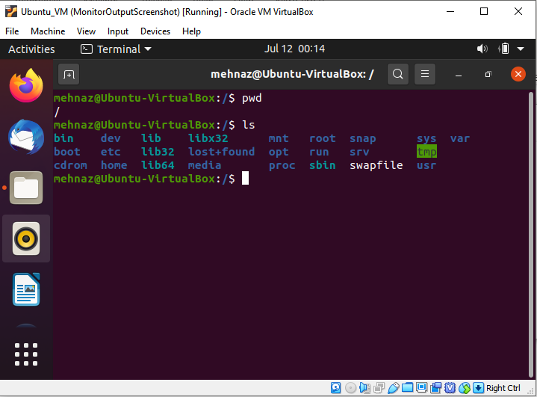

1. Simulate the tasks required to read a C program and compile the program

References

Filesystem Hierarchy Standard

<https://en.wikipedia.org/wiki/Filesystem_Hierarchy_Standard>

Ubuntu Manuals (Command: “man hier” in Ubuntu) - description of the filesystem hierarchy

<http://manpages.ubuntu.com/manpages/focal/en/man7/hier.7.html>

Linux Directory Structure (File System Structure) Explained with Examples

<https://www.thegeekstuff.com/2010/09/linux-file-system-structure/>

What is the purpose of the lost+found folder in Linux and Unix?

<https://unix.stackexchange.com/questions/18154/what-is-the-purpose-of-the-lostfound-folder-in-linux-and-unix/18157#:~:text=The%20lost%2Bfound%20directory%20(not,found%20directory%20by%20inode%20number.>

<https://refspecs.linuxfoundation.org/FHS_3.0/fhs-3.0.html#runRuntimeVariableData>

Compiling a C program:- Behind the Scenes

<https://www.geeksforgeeks.org/compiling-a-c-program-behind-the-scenes/>

Howto: C Programming with Directories on Linux

[https://www.thegeekstuff.com/2012/06/c-directory/#:~:text=h%3E%20DIR%20*opendir(const,first%20entry%20in%20the%20directory.](https://www.thegeekstuff.com/2012/06/c-directory/#:~:text=h%3E%20DIR%20*opendir(const,first%20entry%20in%20the%20directory.)